POSTCARD BOOK REPORT
Have you ever gone on vacation and sent a postcard to someone? Everyone loves to get a postcard! In this report you will write three postcards about different things you learned in your non-fiction book. To begin, think about the important things that you read about. Each postcard should have the following things:
• The name of a person who is interested in the subject to send the postcard to. This could be anyone. Be creative and send it to the president, a movie star, or anyone you can think of (even a person from history) who would be interested in your topic.
• The address of the person. If you don’t know it, then make one up. Be sure it is a complete address with a street, city, state and zip code.
• The message on each of the postcards should be about what you learned in your book.
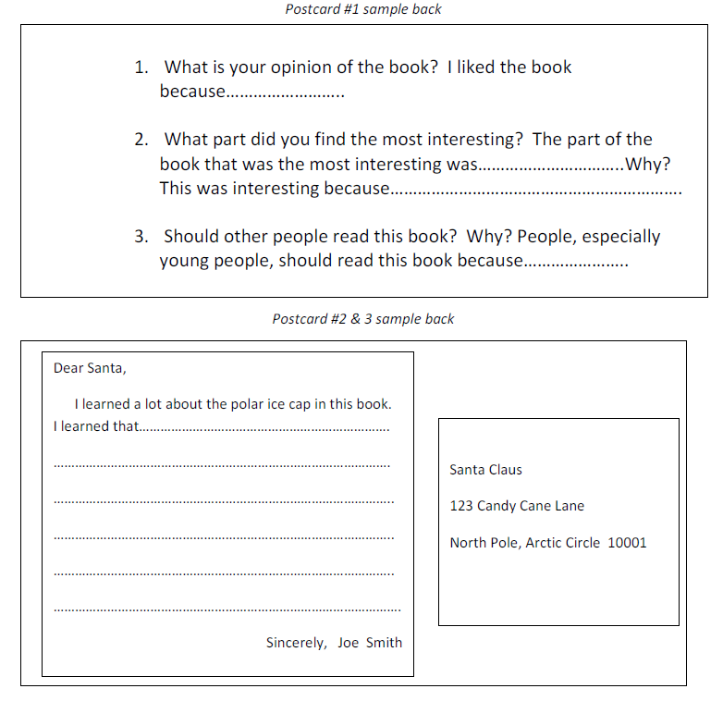
Please create three total postcards. On the front of first postcard should be an alternate book cover for your topic, including the book title, author/editor, and illustrator/photographer information. The answers to the below questions (see postcard #1 sample) should be on the back of this postcard. The other two postcards should have a picture on the front and then the message and address on the back. The picture and the message should be related.

Grading:
• Postcard 1
o Book Title _____/2
o Author _____/2
o Illustrator/Photographer _____/2
o Picture _____/10
o Extra Questions (on back) _____/24
- What is your opinion of the book?
- What part did you find the most interesting? Why?
- Should other people read this book? Why?
• Postcard 2
o Name _____/2
o Address _____/2
o Message _____/15
o Picture _____/6

• Postcard 3
o Name _____/2
o Address _____/2
o Message _____/15
o Picture _____/6
• Conventions _____/5
• This paper attached to the project _____/5

TOTAL POINTS _____/100

